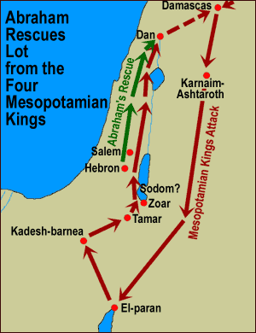
WAR TRAINING

Genesis 14:1-24 Key Verse: 14:19, 20

Part I: The battle of the kings (1-16)

- Read verses 1-12. A. Skim through 14:1-12 and describe the power structure of those days. B. Who won the war (10, 11)? C. In the meantime, what happened to Lot (12)?

- Read verses 13-16. A. When Abram heard about Lot, what did he do? B. What was his tactic? C. With what result?

Part II: Abram meets two kings (17-24)

- Read verses 17-20. A. Who came to meet him (17, 18)? B. How do you characterize these two people? C. What did Melchizedek teach Abram about God? D. How did Abram
respond to his word?

- Read verses 21-24. A. What did the king of Sodom say to Abram? B. But how did Abram respond to him? C. What did he learn about God from this war training?

